CSA0502 – QUERY PROCESSING FOR DATASCIENCE
Lab Programs

11. Highlight NaN Values
Aim
To create a DataFrame, insert NaN values, and highlight the missing values.
Code
import pandas as pd
import numpy as np

df = pd.DataFrame(
np.random.randint(1, 100, (10, 4)),
columns=["A", "B", "C", "D"]
)

# Convert some values to NaN
df.iloc[2,1] = np.nan
df.iloc[5,3] = np.nan
df.iloc[7,0] = np.nan

print(df)

def highlight_nan(val):
if pd.isna(val):
return "background-color:yellow"
return ""

df.style.map(highlight_nan)
Output
A B C D
0 12.0 45.0 18.0 77.0
1 65.0 23.0 84.0 15.0
2 54.0 NaN 35.0 42.0
3 19.0 33.0 56.0 81.0
...
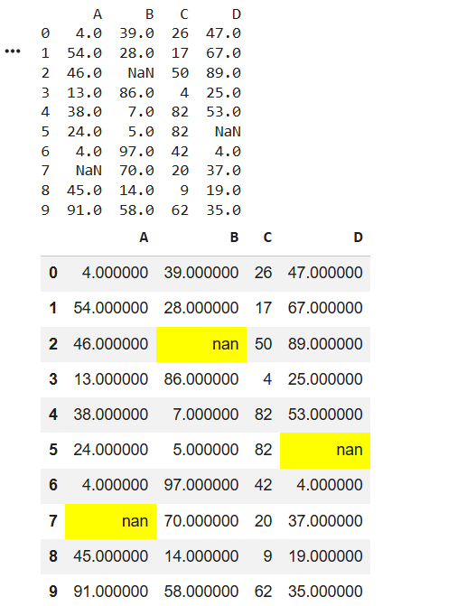
Result
The NaN values were successfully highlighted in the DataFrame.

12. Black Background and Yellow Font
Aim
To create a DataFrame and set the background color to black and the font color to yellow.
Code
import pandas as pd
import numpy as np

df = pd.DataFrame(
np.random.randint(1, 100, (10, 4)),
columns=["A", "B", "C", "D"]
)

print(df)

styled_df = df.style.set_properties(
**{
"background-color": "black",
"color": "yellow"
}
)

styled_df
Output
A B C D
0 25 36 74 58
1 91 14 67 82
2 47 39 28 96
...
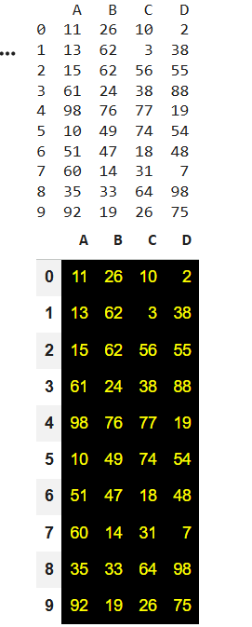
Result
The DataFrame was successfully displayed with a black background and yellow font color.

